**Assignment no 5**

4)

#include <iostream>

using namespace std;

class overloading

{

public:

int pi,a,r;

void area()

{

cout<<"enter pi and r :"<<endl;

cin>>pi>>r;

a=pi*r*r;

cout<<"\n area of circle is :"<<a;

}

void area(int pi)

{

cout<<"enter r :"<<endl;

cin>>r;

a=pi*r*r;

cout<<"\n area of circle is :"<<a;

}

void area(int pi, int r)

{

a=pi*r*r;

cout<<"\n area of circle is :"<<a;

}

};

int main()

{

overloading o;

o.area();

o.area(5,3);

}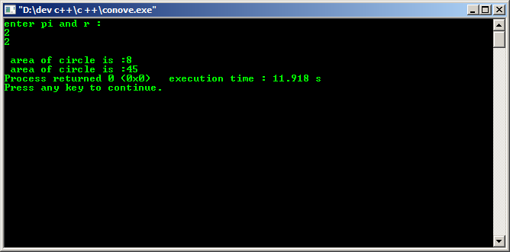

5)

#include <iostream>

using namespace std;

class student

{

private:

int marks,rollno;

public:

void read(int p, int q)

{

marks=p;

rollno=q;

}

void display()

{

cout<<"marks:"<<marks<<endl;

cout<<"rollno:"<<rollno<<endl;

}

};

int main()

{

student s;

s.read(88,12);

s.display();

}

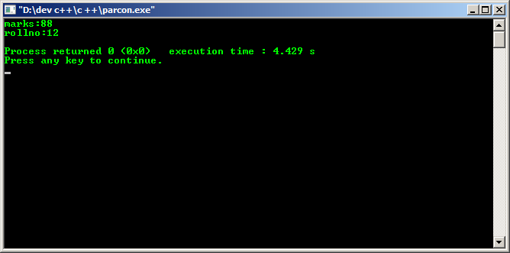

7)

#include<iostream>

using namespace std;

class rect

{

int length, breadth, area;

public:

void read()

{

cout<<"enter the length :";

cin>>length;

cout<<"\n enter the breadth :";

cin>>breadth;

area = length * breadth;

}

void dis()

{

cout<<"\n area is :"<<area;

}

~ rect()

{

length, breadth;

cout<<"\n destroyed";

}

};

int main()

{

rect r;

r.read();

r.dis();

}

